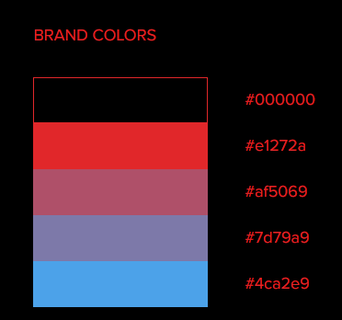

#000000 (Black)

#e1272a (Red)

#af5069 (pink)

#7d79a9 (purple)

#4ca2e9 (blue)

* Home
* Theater show (Avenue | Drama Name |
  + Urdu Theater
  + Hindi Theater
  + English Theater
* Artist gallery (
* Magazines (
* Award Winning (Theater show name |Actor Name | Place | Date of show |
* Upcoming Shows (Date | Time | Location | Actor | Late date of Entry)
* Auditorium (place)(map)
* Feedback & queries (form)
* Contact us (Location Map) (email address)

**For hindi theater with location**

<https://in.bookmyshow.com/explore/hindi-drama-theatre-plays>

drama title image

date of performance

drama name

language

writer

location

**pakistani**

<http://www.itssouthasian.com/best-theatre-artist-of-pakistan/>

**indian**

<https://www.popxo.com/article/20-famous-theatre-artists-in-india-who-are-a-powerhouse-of-talent/>

**english**

<https://www.ranker.com/list/list-of-famous-theatre-actors/reference>

img theater

<https://americanrepertorytheater.org/>

video

<https://americanrepertorytheater.org/shows-events/life-of-pi/>

anmimation text

https://theshed.org/